One-Step Addition and Subtraction Word Problems
2.OA.A.1 Application Mini-Assessment by Student Achievement Partners

OVERVIEW
This mini-assessment explores the important content standard 2.OA.1. It is designed for teachers to use either in the classroom, for self-learning, or in professional development settings. This mini-assessment can help educators:
- Appreciate the intricacies of one-step addition and subtraction word problems;
- Build understanding of the expectations of an important standard in CCSSM;
- Identify strengths and weaknesses in students’ understanding of the operations of addition and subtraction and how they can be used to model situations—whether before, during, or after teaching aspects of this material;
- Illustrate best practices for writing tasks that allow access for all learners; and
- Support mathematical language acquisition by offering specific guidance.
The mini-assessment is also designed for ease of scoring and analyzing classroom results. It consists of thoughtfully designed questions that take very little time to score. Some questions have more than one right answer; in other cases, the choices are diagrams. Teachers wishing to use the mini-assessment in a slightly different way can easily adapt questions using the Word version of the document—for example, by deleting answer choices.

MAKING THE SHIFTS
This mini-assessment promotes strong focus in the classroom; addition and subtraction are at the heart of the Major Work of grade 2. In terms of coherence, content standard 2.OA.1 builds directly on the earlier-grades standards K.OA.1 and 1.OA.1. This mini-assessment targets application, one of the three elements of Rigor.
A CLOSER LOOK
2.OA.1: Use addition and subtraction within 100 to solve one- and two-step word problems involving situations of adding to, taking from, putting together, taking apart, and comparing, with unknowns in all positions, e.g., by using drawings and equations with a symbol for the unknown number to represent the problem.

Standard 2.OA.1 is a good example of how “[t]he Standards are not written at uniform grain size. Sometimes an individual content standard will require days of work, possibly spread over the entire year, while other standards could be sufficiently addressed when grouped with other standards and treated in a shorter time span” (K-8 Publishers’ Criteria Spring 2013, p. 18). Addition and subtraction word problems are the work of the entire K–2 grade band, not the subject of a single lesson or unit. The strong focus of the standards is intended to give teachers and students the time they need.

There are fifteen distinct kinds of single-step addition and subtraction word problem (see Table 1, next page). Students must leave grade 2 with a strong command of addition and subtraction word problems to be prepared for future learning; these sample problem situations will recur in elementary school with fractions, and yet again in middle school with variables. Mastering addition and subtraction situations in a whole-number setting gives students a resource they can draw upon for integrating first fractions, and then variables, into their mathematical repertoires along the way to college readiness.
CONNECTING THE STANDARDS FOR MATHEMATICAL PRACTICE TO GRADE-LEVEL CONTENT
Content standard 2.OA.1 is meaningfully connected to Standards for Mathematical Practice MP2 and MP4. In analyzing and solving these problems, students reason abstractly and quantitatively (MP2), making sense of quantities and their relationships. Practice standard MP4, modeling with mathematics, is involved to some extent whenever students solve word problems with grade-level content, and even more so when they choose addition and subtraction equations to represent problem situations (e.g., question 8); these addition and subtraction equations are mathematical models.

SUPPORT FOR ENGLISH LANGUAGE LEARNERS
This lesson was designed to include specific features that support access for all students and align to best practice for English Language Learner (ELL) instruction and assessment. Go here to learn more about the research behind these supports. Features that support access in this mini-assessment include:
- Tasks that allow for multi-modal representations, which can deepen understanding of the mathematics and make it easier for students, especially ELLs, to give mathematical explanations.
- Tasks that avoid unnecessarily complex language to allow students, especially ELLs, to access and demonstrate what they know about the mathematics of the assessment.
Prior to this mini-assessment, ensure students have had ample opportunities in instruction to read, write, speak, listen for, and understand the mathematical concepts that are represented by the following terms and concepts:
- total
- how many
- fewer
- equation
Students should engage with these terms and concepts in the context of mathematical learning, not as a separate vocabulary study. Students should have access to multi-modal representations of these terms and concepts, including: pictures, diagrams, written explanations, gestures, and sharing of non-examples. These representations will encourage precise language, while prioritizing students’ articulation of concepts. These terms and concepts should be reinforced in teacher instruction, classroom discussion, and student work (for example, through engagement in mathematical routines).
ELLs may need support with the following words found in this mini-assessment:
- before
- choose
- check
- since
- after
In preparation for giving this mini-assessment, teachers should strive to use these words in context so they become familiar to students. It will be important to offer synonyms, rephrasing, visual cues, and modeling of what these words mean in the specific contexts represented in the items in this mini-assessment. Additionally, teachers may offer students the use of a student-friendly dictionary, or visual glossary to ensure they understand what is being asked of them in each item.

Sketch | 
Point | •
Locate | •
An example of a visual glossary for student us
.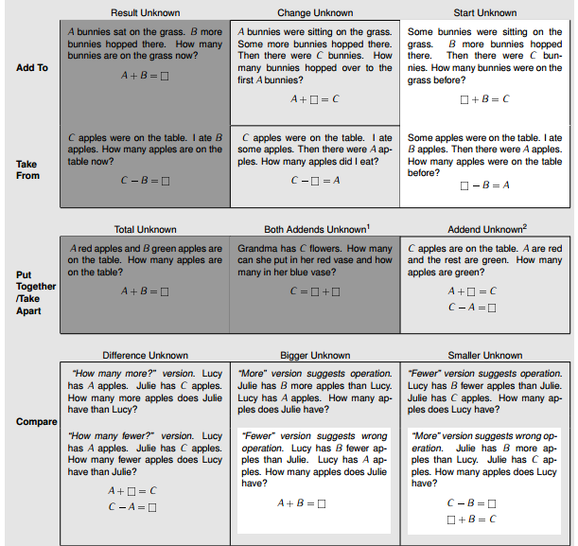
Table 1: Addition and Subtraction Situations by Grade Level

Each question on the mini-assessment maps to a situation type in Table 1, as shown below. Each number below corresponds to the question on the assessment that uses the indicated situation type. Note: a summative assessment for grade 2 might include more of the unshaded situation types. This assessment was designed to showcase the variety of types with all 15 types in just 15 questions.

 | Result Unknown | Change Unknown | Start Unknown
Add To | 3 | 10 | 2
Take From | 1 | 11 | 7
 | Total Unknown | Both Addends Unknown | Addend Unknown
Put Together/Take Apart | 4 | 5 | 13
 | Difference Unknown | Bigger Unknown | Smaller Unknown
Compare | 12 | 9 | 14
Compare | 8 | 6 | 15

Name: ___________________________________ | Date: ____________

- Tara had 37 red pens. She gave Jim 8 of her red pens.

How many red pens does Tara have now?

- Betsy gave Shawn 8 red pens. Now Shawn has 11 red pens.

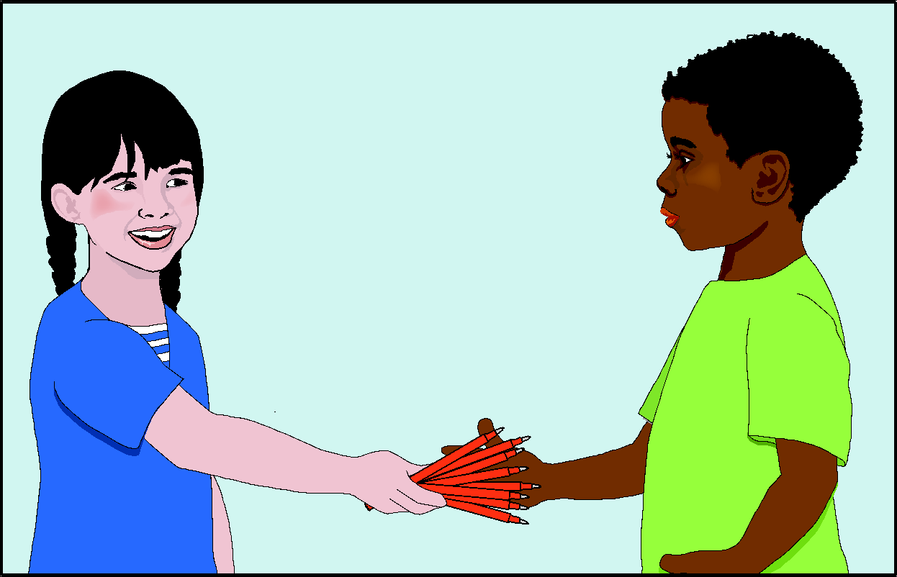

How many red pens did Shawn have before?

- Jen has 7 blue pens. Then she buys 18 more blue pens.

How many blue pens does Jen have now?

- Jose has 11 red pens and 29 blue pens.

How many total pens does Jose have?

- Tara needs to buy 48 markers.

Choose the answer showing a total of 48 markers.
- 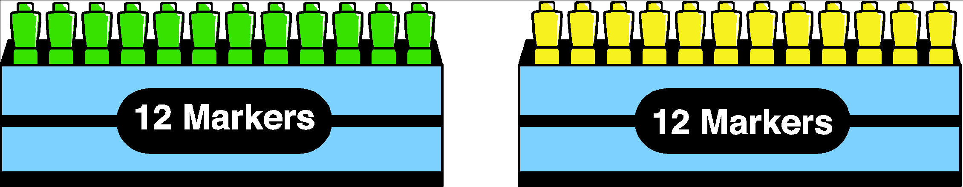

- 

- 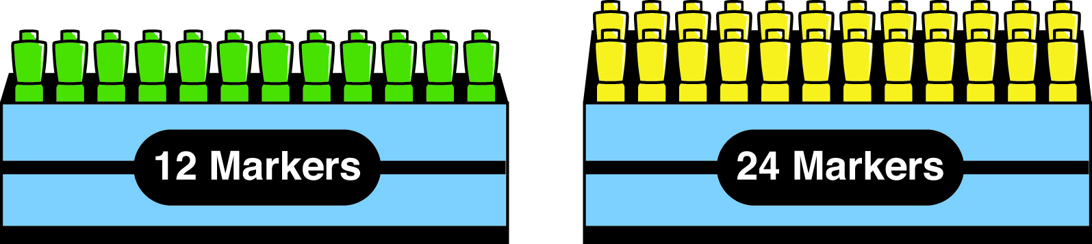

- 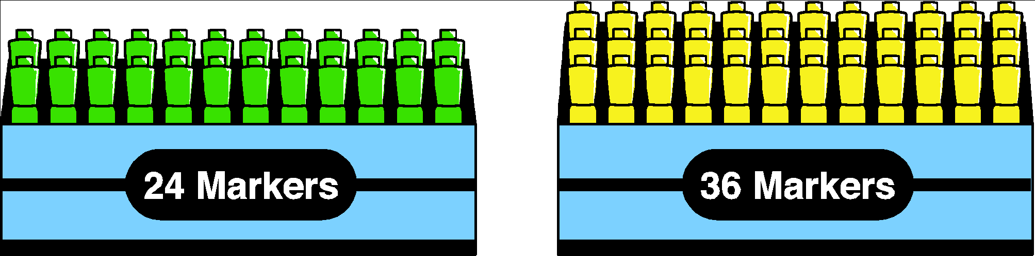

- Molly’s class has 3 fewer students than Sam’s class. Molly’s class has 25 students.

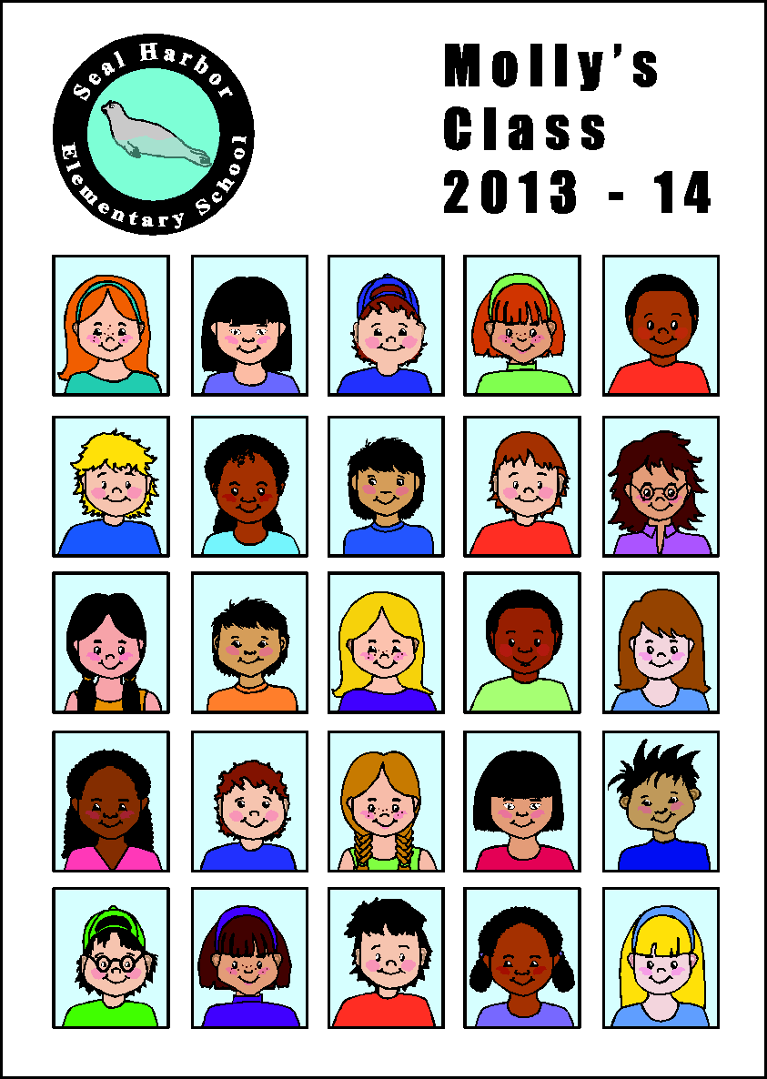

How many students are in Sam’s class?

- Since the first day of school, 4 students left Norma’s class. Norma’s class now has 25 students.

How many students were in Norma’s class on the first day of school?

- 43 students are playing tag at recess. 25 students are playing soccer.

Decide whether each equation can be used to find out how many fewer students are playing soccer than playing tag? Check YES or NO for each row.

EQUATION | YES | NO
25 + ? = 43
? – 25 = 43
43 + 25 = ?
43 – 25 = ?

- 18 students in Bill’s class buy pizza. 8 more students buy pizza in Ying’s class than in Bill’s class.
How many students in Ying’s class buy pizza?

- There were 32 students in Jaden’s class eating lunch. Then, more students joined Jaden’s class. Now there are 86 total students eating lunch.
How many students joined Jaden’s class?

- There were 74 apples at the start of lunch. After the second graders ate some, there were 24 apples.
How many apples did the second graders eat?

- On Friday, 46 students bought ice cream and 53 students bought popcorn.
How many more students bought popcorn than ice cream?

13. There are two first grade classes at a school. There are 16 students in one class. There are 28 total students in first grade.

Which equation can you use to find the number of students in the other class?

  - 16 – = 28
  - 16 + = 28
  - 16 – 28 =
  - 16 + 28 =

14. Mrs. Baca’s class has 14 fewer students than Mr. Cole’s class. Mr. Cole’s class has 31 students.
Which equation can be used to find the number of students in Mrs. Baca’s class?
- ▼ – 14 = 31
- ▼ + 31 = 14
- ▼ + 14 = 31
- 31 + 14 = ▼

15. David’s book has 26 more pages than Elam’s book. There are 48 pages in David’s book.
Decide whether each equation can be used to find the number of pages in Elam’s book? Check YES or NO for each row.

EQUATION | YES | NO
48 = ◊ + 26
◊ – 26 = 48
48 + 26 = ◊
48 – 26 = ◊

1. Tara had 37 red pens. She gave Jim 8 of her red pens.
How many red pens does Tara have now? 29

2. Betsy gave Shawn 8 red pens. Now Shawn has 11 red pens.

How many red pens did Shawn have before? 3

3. Jen has 7 blue pens. Then she buys 18 more blue pens.
How many blue pens does Jen have now? 25

4. Jose has 11 red pens and 29 blue pens.
How many total pens does Jose have? 40

5. Tara needs to buy 48 markers.
Choose the answer showing a total of 48 markers.

6. Molly’s class has 3 fewer students than Sam’s class. Molly’s class has 25 students.

How many students are in Sam’s class? 28
7. Since the first day of school, 4 students left Norma’s class. Norma’s class now has 25 students.
How many students were in Norma’s class on the first day of school? 29

8. 43 students are playing tag at recess. 25 students are playing soccer.
Decide whether each equation can be used to find out how many fewer students are playing soccer than playing tag? Check YES or NO for each row.

EQUATION | YES | NO
25 + ? = 43 | X
? – 25 = 43 |  | X
43 + 25 = ? |  | X
43 – 25 = ? | X

9. 18 students in Bill’s class buy pizza. 8 more students buy pizza in Ying’s class than in Bill’s class.
How many students in Ying’s class buy pizza? 26

10. There were 32 students in Jaden’s class eating lunch. Then, more students joined Jaden’s class. Now there are 86 total students eating lunch.
How many students joined Jaden’s class? 54

11. There were 74 apples at the start of lunch. After the second graders ate some, there were 24 apples.
How many apples did the second graders eat? 50

12. On Friday, 46 students bought ice cream and 53 students bought popcorn.
How many more students bought popcorn than ice cream? 7

13. There are two first grade classes at a school. There are 16 students in one class. There are 28 total students in first grade.

Which equation can you use to find the number of students in the other class?

- 16 – = 28
- 16 + = 28
- 16 – 28 =
- 16 + 28 =

14. Mrs. Baca’s class has 14 fewer students than Mr. Cole’s class. Mr. Cole’s class has 31 students.
Which equation can be used to find the number of students in Mrs. Baca’s class?
- ▼ – 14 = 31
- ▼ + 31 = 14
- ▼ + 14 = 31
- 31 + 14 = ▼

15. David’s book has 26 more pages than Elam’s book. There are 48 pages in David’s book.
Decide whether each equation can be used to find the number of pages in Elam’s book? Check YES or NO for each row.

EQUATION | YES | NO
48 = ◊ + 26
◊ – 26 = 48
48 + 26 = ◊
48 – 26 = ◊

The difficulty of the situation type is indicated by boxes placed next to each question number:
( ) No box: An easier situation type, generally first introduced in Kindergarten.
(∙) Single box: An intermediate situation type, generally first introduced in Grade 1 and mastered in Grade 1 or Grade 2.
(∙∙) Double box: A harder situation type, generally introduced in Grade 2 and mastered by or before the end of that year.
Note, a summative assessment for grade 2 might include more of the harder situation types (∙∙). This assessment was designed to showcase the variety of types with all 15 types in just 15 questions.

Student Name: ______________________________________________________________

Question | Correct Answer
1 | 29
2 ∙∙ | 3
3 | 25
4 | 40
5 | B
6 ∙∙ | 28
7 ∙∙ | 29
8 ∙ | Y, N, N, Y
9 ∙ | 26
10 ∙ | 54
11 ∙ | 50
12 ∙ | 7
13 ∙ | B
14 ∙ | C
15 ∙∙ | Y, N, N, Y
Totals:
Possible: | 15

Concerns (circle all that apply): Incorrect Situation Model

Incorrect Computation: Multi-digit “Facts”

For more on the Major Work of the Grade, see achievethecore.org/focus.
From page 9 of the Progressions for the Common Core State Standards in Mathematics, Draft K-5 Progression on Counting and Cardinality and Operations and Algebraic Thinking; see http://ime.math.arizona.edu/progressions/.

